Thank you for your kind donation to support Safari West Wildlife Foundation’s youth programs at Safari West! The Foundation’s programs exist through support like yours and fundraising at our annual gala “An Evening on the Serengeti.” This fundraiser, scheduled for September 7, 2024, is critical to the success of the Foundation moving into 2025 to support our Safari West LIVE, Discover Africa, and Junior Keeper programs.

Safari West wildlife foundation
3115 Porter Creek Road, Santa Rosa, CA 95404
Our programs impact the education and well-being of thousands of children every year who would not otherwise have an opportunity to experience live wild animals and access conservation, science and biology lessons otherwise not learned in a conventional classroom. Safari West LIVE broadcasts a live interactive safari trek to hospitals in Sonoma County and across the United States, reaching over 65,000 hospital beds in 2023. Discover Africa offers field trips to Title 1 underserved schools for grades 3-12 in Sonoma/Napa and the Greater Bay Area, reaching 880 school children in 2023. Junior Keepers is a launch-pad program for teens interested in starting their education and experience in animal, science, and biology fields.
We hope you will consider expanding your reach as a “Conservation Hero” and support our programs. Our current budget is in a shortfall of 40% and we need your support now more than ever. As a thank you for your contribution, your logo and business name will be included in our annual gala’s program, repeated in our outreach for the fundraiser, and thanked during and after the event. You and your team will benefit from knowing you are supporting programs with a direct benefit to our community.
Your support allows these programs to continue to "Inspire Wildlife Stewards for Life," and we are honored you are a part of our combined success.
Sincerely,
Lisa Chapman
Chair, Safari West Wildlife Foundation Annual Gala

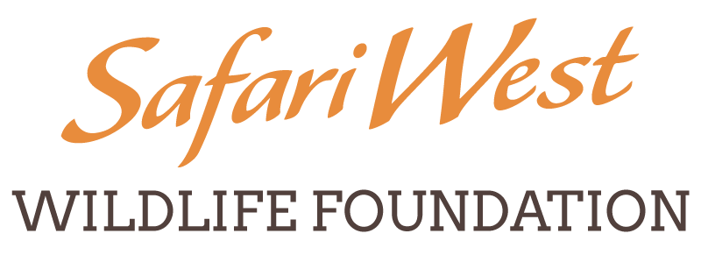
Safari West Wildlife Foundation Donor Form for Goods or Services
Donor Name: _Click or tap here to enter text.
Organization Name: _Click or tap here to enter text.
(If no organization name, tax form will be issued to Donor)
Mailing Address: _Click or tap here to enter text.
City: _Click or tap here to enter text. State: Click or tap here to enter text.
Zip: _Click or tap here to enter text. Phone: _Click or tap here to enter text.
Email: _Click or tap here to enter text.
Please provide a description of the item you are donating:
Click or tap here to enter text.

Please provide an approximate retail value: $_Click or tap here to enter text.
(Tax advisor should determine tax deductible amount)

Signature: __Click or tap here to enter text.
Thank you! Your donation supports our charitable mission. 501 (c)(3) #91-1837240
Your contribution is deductible to the fullest extent allowed by law.

Please complete and email to:
Tori Goff tgoff@safariwest.com 707-566-3606 or
Paula Johnson paula@safariwestfoundation.org 707-566-3612.

